Project Title
Security Review and Upgrade Plan for XDCValidator Smart Contract

Objective
To conduct a comprehensive security audit of the existing XDCValidator smart contract, identify any vulnerabilities, recommend and implement fixes via GitHub pull requests (PRs), and prepare a secure and structured migration plan to a new, upgraded version of the contract. Access to the existing XDCValidator codebase on GitHub

Comprehensive Research Plan
- Security Audit Report
  - Thorough review of the existing XDCValidator.sol contract
  - Identification and documentation of:
    - Critical, high, medium, and low-risk vulnerabilities
    - Outdated patterns, gas inefficiencies, and governance risks
  - Risk matrix with severity ratings
- Proposed Fixes
  - Patch recommendations for all discovered issues
  - Submission of one or more GitHub PRs against the original repo
  - Inline documentation explaining the fix logic and rationale
- Secure Contract Migration Plan
  - Design of a new XDCValidatorV2.sol contract with:
    - Updated Solidity version (≥0.8.23)
    - Best practices in access control, upgradability, and validator management
    - Secure handling of validator slashing, rewards, and staking logic
  - Deployment plan including:
    - Audit and test coverage
    - Community feedback loop (if applicable)
    - Step-by-step validator migration with minimal downtime
    - Rollback and contingency strategy
- Documentation
  - Markdown-based report with:
    - Overview of audit findings
    - Architecture and rationale for new validator contract
    - Upgrade/migration instructions

Tools & Methodologies
- Static Analysis: Slither, Mythril, Remix, Solhint, Solidity Scan
- Manual Review: Solidity style guide, reentrancy and permission audits
- Testing Framework: Hardhat/Foundry with ≥90% code coverage
- Versioning: Adherence to SemVer for contract upgrade tagging
- Standards: Follows OpenZeppelin, EIP-2535 (if applicable), EIP-173 (Ownable), etc.

Table of Contents

- Summary
  - Executive Summary
  - Vulnerability Summary
  - Deployed Addresses

- Review Notes
  - Solidity Smart Contract Module (XDCValidator.sol) – Risk Matrix
  - Node Binaries – The four *. go files

    - XDPoSChain/contracts/utils.go
    - XDPoSChain/params/config.go
    - XDPoSChain/common/constants.go
    - XDPoSChain/eth/util/util.go)

- Findings
  - Static Analysis – Remix, Solhint, Slither, Solidity Scan
  - Dynamic Analysis - Mythril
  - Custom Dynamic Analysis by Attack/Vulnerability Recreation on XDC Apothem

- Enhancements
  - Solidity Smart Contract Module (XDCValidatorV2.sol)
  - Static Analysis – Remix, Solhint, Slither, Solidity Scan
  - Dynamic Analysis - Mythril
  - Custom Dynamic Analysis by Attack/Vulnerability Recreation on XDC Apothem
  - Final Assessment Summary

- Migration Plan

- Conclusion

Summary

Executive Summary

Ecosystem - XDC | Methods – Manual Review, Static Analysis, Dynamic Analysis, Custom Dynamic Analysis by Attack/Vulnerability Recreation on XDC Apothem | Language – Solidity, Golang, Java Script
Key Components – XDCValidator.sol, util.go, utils.go, config.go, constants.go | Codebase - XDPoSChain | Repository: https://github.com/CCoE-UEMK/XDCSmartContractSecurityAudit

Vulnerability Summary

Risk Level | Total | Resolved/Partially Addressed | Safe in Apothem | Not Fixed / Acknowledged
Critical | 3 | 🟩🟩 (2) | 🟦 (1) | —
High | 3 | 🟩🟩 🟩 (3) | — | —
Medium | 8 | 🟩🟩🟩🟩 🟩 🟩 (6) | — | 🟨🟨 (2)
Low | 8 | 🟩🟩🟩🟩🟩 (5) | — | 🟨🟨🟨 (3)
Informational | 2 | 🟩🟩 (2) | — | —
Total | 24 | 18 | 1 | 5

Legend:
- 🟩 Resolved / Addressed
- 🟦 Safe in Apothem (validated, no risk)
- 🟨 Acknowledged or Acceptable Risk
Summary:
- 18 out of 24 issues (75%) are fully resolved or addressed.
- 1 issue was flagged but turned out safe through Apothem testing.
- 5 issues remain acknowledged or deferred with acceptable risk and monitoring.

Deployed Addresses
Codebase | Attack Recreated on Apothem | Deployed Address
XDCValidator.sol | Reentrancy | "validator": "0x440b1569357261edC0d59f8d8aC9AE2Ef4216B85"  "attacker": "0x102E347de2498fb337e848679A99b67d4c3138c6"
XDCValidator.sol | Access Control Misconfiguration | "validator": "0x8d8D34163FEe57f5802ACe69eD3ed6bb70D9506f"
XDCValidator.sol | Governance fragility | “validator”: “0x7660F38A9E7Cd33cFf9860b3Fa6Ca2d164587855”
XDCValidator.sol | Deletes on Mappings of Dynamic Arrays (Candidate_Resign) – Leaves Holes Vulnerability /For-loop-over dynamic array | “validator”: “0x65870eEF056300aC034Da495184E3094Cb3Cc015”
XDCValidatorV2.sol | Reentrancy | "validator": "0xCDCa140e9eBE2B4B38f6aEA55F265374105500cf"  "attacker": "0x9A28fcC1597eae8AB80ba6d289ec51433B9ED095"
XDCValidatorV2.sol | Governance fragility | “validator”: “0xCe1685B81d565661F4FaeB678a49c7D42210108b”
XDCValidatorV2.sol | Candidate_Resign/For-loop-over dynamic array | “validator”: “0xa45c134b628f7F8dA09C69BD38870caeBAB712Fb”

Review Notes

a. Solidity Smart Contract Module (XDCValidator.sol)

Risk Matrix

Severity | ID | Issue | Tools | Location | Description | Recommendation
Critical | C-01 | Old Solidity version with known bugs | Slither/Solhint | XDCValidator.sol:2, SafeMath.sol:1 | Pragma ^0.4.21 is outdated and has known vulnerabilities. | Upgrade to ^0.8.x; Follow Checks-Effects-Interactions pattern; update state before transfer.
Critical | C-02 | Incorrect access control on sensitive functions | Solidity Scan | XDCValidator.sol:2 | Functions missing onlyOwner or similar checks | Try calling sensitive functions like addCandidate, setConfig, forceWithdraw. If these succeed, access control is missing.
Critical | C-03 | Reentrancy vulnerability | Slither/Remix | withdraw() | External call before state change | Apply Checks-Effects-Interactions
High | H-01 | Deletion on mappings | Slither | delete validatorsState[candidates[i]] | Deletes mapping with struct | Use isDeleted flags
High | H-02 | Governance fragility | Slither/Remix | candidates | owners | Loops can exceed gas
High | H-03 | Deletes on arrays | Remix | delete candidates[i] | Leaves holes | Use swap & pop
Medium | M-01 | Costly operations inside loops | Slither/Remix | XDCValidator.sol:247,259 | voteInvalidKYC; Loops with deletes and decrements can consume high gas and may fail beyond block gas limit. | Deletes + state changes inside loop; Consider limiting loop iterations or refactoring to avoid costly deletes.
Medium | M-02 | Push with user control | Slither | voters[_candidate].push | Unbounded growth | Cap entries
Medium | M-03 | Array length not cached | Slither | XDCValidator.sol:219,247,259 | Repeated access of dynamic array length in loop condition leads to unnecessary gas costs. | Cache array length in a local variable before the loop.
Medium | M-04 | Integer division truncation | Remix | 10/100=0 | Silent truncation | Scale before division
Medium | M-05 | Delete from dynamic array leaves gaps | Remix | XDCValidator.sol:220 | Using delete on arrays leaves empty slots and keeps length the same. | Manually shift elements and reduce array length.
Medium | M-06 | Unbounded loop over dynamic array | Remix | XDCValidator.sol:219,247,259 | Loop iterations depend on storage array size, which can exceed block gas limit. | Test carefully or limit maximum array sizes.
Medium | M-07 | Misuse of assert | Remix | assert(x) | Use assert only for invariants | Use require
Medium | M-08 | Missing visibility | Solhint | multiple | Defaults to public | Explicitly declare
Low | L-01 | Naming style | Solhint | KYCString | mixedCase violations | Refactor names
Low | L-02 | Unsafe imports | Solhint | import SafeMath.sol | Global imports | Use import as
Low | L-03 | Many state vars | Solhint | >15 | Complex upgrades | Use structs
Low | L-04 | Compiler semver mismatch | Solhint | ^0.4.21 vs ^0.5.8 | Conflicting versions | Align versions
Low | L-05 | Events not indexed | Manual | Withdraw | Hard to filter | Add indexed
Low | L-06 | Repeated logic | Manual | multiple | Repeated msg.sender checks | Refactor common code
Low | L-07 | Functions lack explicit visibility | Solhint | Various lines | Functions should explicitly declare visibility for clarity and security. | Add explicit visibility (public/private/internal/external) to all functions.
Low | L-08 | Non-mixedCase naming | Slither | Various lines | Variables and parameters not following mixedCase style reduces readability. | Rename to mixedCase to comply with Solidity style guidelines.
Info | I-01 | Constant/View/Pure missing | Remix | Various lines | Functions that could be marked view or pure are not marked, leading to unclear gas estimation. | Use view or pure keywords where applicable.
Info | I-02 | Mythril no issues detected | Mythril | Full Contract | Symbolic execution did not find critical exploits. | Continue using Mythril for periodic scans after updates.

B. Node Binaries – The four *. go files (reward logic files)
    - XDPoSChain/contracts/utils.go – core reward calculations
    - XDPoSChain/params/config.go – percentage calculations
    - XDPoSChain/common/constants.go – percentage calculations
    - XDPoSChain/eth/util/util.go) – inflation adjustments
- Focus: Reward distribution logic, voter and validator calculations, randomness for validator set.
Summary of Manual Findings
Category | Count
Critical | 0
High | 0
Medium | 3
Low | 2
Informational/Style | 0

The contract’s Go-based logic is cleanly structured, with no critical vulnerabilities detected. However, there are several areas where medium and low-level security or architectural concerns were noted.
- The reward logic in the XDPoS implementation calculates and distributes rewards to masternodes, their voters, and the foundation wallet.
- It uses a proportional share model based on signing activity and stake caps.
- The consensus & reward configurations (like Epoch, RewardCheckpoint, and Reward amount) are centrally controlled via config.go.
- The core security risks come from integer division truncations, potential overflows (though unlikely in big.Int), improper randomization that could be manipulated, and hard-coded percentages that could lead to governance issues if not well-audited.

Overall manual analysis
- No critical vulnerabilities were found.
- But medium risks exist around misuse of division logic and incentive manipulation via voter caps.

Main Security Observations
1. Integer division truncation in reward calculation
- In CalculateRewardForSigner and GetRewardBalancesRate, integer division (Div) causes fractional shares to be truncated.
- This could slightly underpay participants if total reward isn’t perfectly divisible.
2. Unbounded iteration over voters
- Iterates over all voters with no explicit gas protection or cap.
- Could become a problem on very large staking pools.
3. Hard-coded percentages
- Rewards are split by common.RewardMasterPercent, common.RewardVoterPercent, and common.RewardFoundationPercent.
- Changes to these constants impact all rewards, requiring strict governance.
4. Randomization logic for validators
- Uses rand.Seed(time.Now().UnixNano()) with local randomness which is not cryptographically secure and potentially predictable.
5. Encryption & decryption for secrets
- Uses AES CFB with rand.Seed which is fine for ephemeral randomness but should ideally use secure randomness sources consistently.
Detailed Findings

- Medium
ID | Issue | Location | Description | Recommendation
R1 | Integer division truncates rewards | `utils.go:199,370` | Uses `big.Int.Div` which truncates decimals, potentially causing fractional rewards to vanish silently. | Use a residual approach to track & redistribute leftover tokens, or log skipped fractions for transparency.
R2 | Incentive manipulation via voter caps | `utils.go:458` | Voter caps heavily influence reward shares. Large stakeholders can concentrate rewards. | Apply damping curves or cap maximum influence to avoid whale centralization.
R3 | Non-secure randomness | `utils.go:414` | Uses `rand.Seed(time.Now().UnixNano())` for shuffling validators. Predictable and not cryptographically secure. | Use `crypto/rand` or blockchain entropy sources (like VRF or blockhash).

- Low
ID | Issue | Location | Description | Recommendation
R4 | Hard-coded reward percentages | `utils.go:444` | Splits such as `RewardMasterPercent`, `RewardVoterPercent`, and `RewardFoundationPercent` are fixed in config. | Make these configurable via governance or chain parameters.
R5 | Unbounded iteration over voters | `utils.go:448` | Loops over all voters without bounds, which may cause issues if voter list becomes very large. | Set practical limits, or process in batches (lazy payout)

Recommendations Summary
Area | Improvement
Reward truncation | Use residual carry-over or micro-denomination logs.
Voter caps | Employ anti-whale logic like quadratic voting or sigmoid dampening.
Randomness | Replace `math/rand` with `crypto/rand` or beacon randomness.
Hard-coded params | Read from config or on-chain governance proposals.
Looping over voters | Use batch payouts or off-chain aggregation to stay scalable.

Conclusion
This reward logic is robust for standard scenarios but should adopt stronger randomness and governance configurability to resist future manipulation or subtle incentive attacks.

Findings

Static Analysis – Remix, Solhint, Slither, Solidity Scan

- Slither, Remix Static Analyzer, Solhint
Key Findings
Tool | Highlights
Slither | Detected array operations with user-controlled length, costly loops, possible reentrancy, outdated compiler pragma.
Remix | Found checks-effects-interaction pattern violation, unbounded loops, use of delete, missing guard conditions.
Solhint | Identified compiler version mismatch, excessive state variables, missing visibility markers.

Further Recommendations
- Refactor withdraw to follow checks-effects-interaction strictly.
- Cache array lengths inside loops.
- Avoid delete on dynamic arrays without proper shifting.
- Upgrade compiler pragma to ^0.8.0 to utilize built-in overflow checks.
- Use explicit require for input validation and ensure all state variables/functions have visibility declared.
Conclusion
While symbolic execution found no critical exploits, static analysis revealed multiple areas to improve safety, gas efficiency, and maintainability. Addressing these issues will significantly reduce future risks.

- SolidityScan result for Basic - 2/XDCValidator.sol
# | NAME | SEVERITY | CONFIDENCE | DESCRIPTION | REMEDIATION
1. | INCORRECT ACCESS CONTROL | critical | 1 | Access control plays an important role in the segregation of privileges in smart contracts and other applications. If this is misconfigured or not properly validated on sensitive functions, it may lead to loss of funds, tokens and in some cases compromise of the smart contract.  The contract is importing an access control library but the function is missing the modifier. | Not Available
2. | DELETING A MAPPING WITHIN A STRUCT | high | 0 | The contract was found to be using a mapping (X) containing a struct (Y). This struct also contains another mapping (Z).  The vulnerability arises when the an item is deleted from mapping (X). This does not delete data from mapping (Z). The remaining data may compromise the contract. | Not Available
3. | IMPROPER ARRAY DELETION | medium | 2 | Elements inside Arrays in solidity can be deleted using delete or .length = 0 directives. However, this will NOT shift the elements in your array and will leave an element of string 0 in your array.  When a new element is added to the same array, the size of the array keeps on increasing if the length is not adjusted for the deleted element. This creates gigantic arrays and may lead to an Out-of-Gas exception. | Not Available
4. | BLOCK.NUMBER INCONSISTENCIES ON VARIOUS L2S | medium | 0 | On Optimism, block.number represents the L2 block number, whereas on Arbitrum, it reflects the L1 block number, necessitating the use of ArbSys(address(100)).arbBlockNumber() on Arbitrum.  Caution is advised as L2 block numbers may occur more frequently than L1 block numbers, leading to timing inconsistencies, especially in voting scenarios across multiple chains. Notably, OZ has addressed this concern in version 4.9 by modifying their governor code to use a clock instead of block numbers. | Not Available
5. | UNCHECKED ARRAY LENGTH | medium | 2 | Ethereum is a very resource-constrained environment. Prices per computational step are orders of magnitude higher than with centralized providers. Moreover, Ethereum miners impose a limit on the total number of Gas consumed in a block. If array.length is large enough, the function exceeds the block gas limit, and transactions calling it will never be confirmed.  for (uint256 i = 0; i < array.length ; i++) { cosltyFunc(); }  This becomes a security issue if an external actor influences array.length.  E.g., if an array enumerates all registered addresses, an adversary can register many addresses, causing the problem described above. | Not Available
6. | MODIFYING REFERENCE TYPE PARAMETERS | low | 2 | The contract should always explicitly define the storage locations, either storage or memory, when passing arrays inside function parameters.  Sometimes it may happen that the developer wants to update a state variable but failed to explicitly define the storage location in the function parameters which will lead to incorrect values being updated in the state variable. | Not Available
7. | USE OF FLOATING PRAGMA | low | 2 | Solidity source files indicate the versions of the compiler they can be compiled with using a pragma directive at the top of the solidity file. This can either be a floating pragma or a specific compiler version.  The contract was found to be using a floating pragma which is not considered safe as it can be compiled with all the versions described. | Not Available
8. | OUTDATED COMPILER VERSION | low | 2 | Using an outdated compiler version can be problematic especially if there are publicly disclosed bugs and issues that affect the current compiler version. | Not Available
9. | EVENT BASED REENTRANCY | low | 1 | In a Re-entrancy attack, a malicious contract calls back into the calling contract before the first invocation of the function is finished. This may cause the different invocations of the function to interact in undesirable ways, especially in cases where the function is updating state variables after the external calls.  In the case of event-based Re-entrancy attacks, events are emitted after an external call leading to missing event calls. | Not Available
10. | MISSING ZERO ADDRESS VALIDATION | low | 2 | The contract is found to lack proper validation for zero address inputs in critical functions, particularly where an 'address' input is expected, like during initialization or setting ownership. Failure to validate zero addresses can result in unwanted contract states, such as having critical roles or operations reference the zero address (0x0), which is universally considered an invalid and non-operational address within Ethereum, potentially leading to the loss of assets or control over the contract's functionality. | Not Available
11. | BLOCK VALUES AS A PROXY FOR TIME | informational | 1 | Contracts often need access to time values to perform certain types of functionality. Values such as block.timestamp and block.number can be used to determine the current time or the time delta. However, they are not recommended for most use cases.  For block.number, as Ethereum block times are generally around 14 seconds, the delta between blocks can be predicted. The block times, on the other hand, do not remain constant and are subject to change for a number of reasons, e.g., fork reorganizations and the difficulty bomb.  Due to variable block times, block.number should not be relied on for precise calculations of time. | Not Available
12. | CONTRACT NAME SHOULD USE PASCALCASE | informational | 2 | In Solidity, it's advisable to follow the established style guide, which dictates that contract names should be in PascalCase and match their respective file names. This adherence to consistent naming conventions not only enhances code readability and maintainability but also facilitates smoother collaboration among developers. By aligning with these recommendations, you make your code more accessible to others and reduce the likelihood of naming conflicts, contributing to a well-organized and efficient coding environment. | Not Available
13. | REQUIRE WITH EMPTY MESSAGE | informational | 2 | A require statement was detected with an empty message. It takes two parameters and the message part is optional. This is shown to the user when and if the require statement evaluates to false. This message gives more information about the statement and why it gave a false response. | Not Available
14. | IF-STATEMENT REFACTORING | informational | 0 | In Solidity, we aim to write clear, efficient code that is both easy to understand and maintain. If statements can be converted to ternary operators. While using ternary operators instead of if/else statements can sometimes lead to more concise code, it's crucial to understand the trade-offs involved. | Not Available
15. | MISSING STATE VARIABLE VISIBILITY | informational | 0 | Visibility modifiers determine the level of access to the variables in your smart contract. This defines the level of access for contracts and other external users. It makes it easier to understand who can access the variable. | Not Available
16. | MISSING INDEXED KEYWORDS IN EVENTS | informational | 2 | Events are essential for tracking off-chain data and when the event paraemters are indexed they can be used as filter options which will help getting only the specific data instead of all the logs. | Not Available
17. | USE CALL INSTEAD OF TRANSFER OR SEND | informational | 2 | The contract was found to be using transfer or send function call. This is unsafe as transfer has hard coded gas budget and can fail if the user is a smart contract. | Not Available
18. | VARIABLES SHOULD BE IMMUTABLE | informational | 0 | Constants and Immutables should be used in their appropriate contexts.  constant should only be used for literal values written into the code. immutable variables should be used for expressions, or values calculated in, or passed into the constructor. | Not Available
19. | AVOID ARITHMETIC DIRECTLY WITHIN ARRAY INDICES | informational | 1 | Using arithmetic directly within array indices (array[i + 2]) can introduce risks such as accessing invalid positions, leading to runtime errors. It also reduces code clarity, making it harder to debug and maintain. Instead, compute the index beforehand and store it in a variable for better readability and reliability. | Not Available
20. | GAS OPTIMIZATION FOR STATE VARIABLES | gas | 2 | Plus equals (+=) costs more gas than addition operator. The same thing happens with minus equals (-=).  Lines: ["241:241"] | Consider  - addition operator over plus equals  - subtraction operator over minus equals  - division operator over divide equals  - multiplication operator over multiply equals
21. | DEFAULT INT VALUES ARE MANUALLY RESET | gas | 0 | The contract is found to inefficiently reset integer variables to their default value of zero using manual assignment. In Solidity, manually setting a variable to its default value does not free up storage space, leading to unnecessary gas consumption. Instead, using the .delete keyword can achieve the same result while also freeing up storage space on the Ethereum blockchain, resulting in gas cost savings.  Lines: ["216:216","226:226"] | To optimize gas usage, replace manual resets of integer variables with the .delete keyword. This not only sets the variable to its default value but also frees up storage space, leading to reduced gas costs.
22. | ARRAY LENGTH CACHING | gas | 2 | During each iteration of the loop, reading the length of the array uses more gas than is necessary. In the most favorable scenario, in which the length is read from a memory variable, storing the array length in the stack can save about 3 gas per iteration. In the least favorable scenario, in which external calls are made during each iteration, the amount of gas wasted can be significant.  Lines: ["122:132","218:223"] | Consider storing the array length of the variable before the loop and use the stored length instead of fetching it in each iteration.
23. | AVOID ZERO-TO-ONE STORAGE WRITES | gas | 2 | Writing a storage variable from zero to a non-zero value costs 22,100 gas (20,000 for the write and 2,100 for cold access), making it one of the most expensive operations. This is why patterns like OpenZeppelin’s ReentrancyGuard use 1 and 2 instead of 0 and 1—to avoid the high cost of zero-to-non-zero writes. Non-zero to non-zero updates cost only 5,000 gas.  Lines: ["114:114","115:115","116:116","117:117","118:118","119:119","152:152","217:217","249:249"] | To mitigate this gas inefficiency, consider initializing storage variables to non-zero values during contract deployment if possible. Alternatively, design contract logic to minimize the number of times storage variables are set from zero to non-zero values. This can be achieved by setting default non-zero values where applicable or by batching storage updates to reduce the frequency of costly initializations.
24. | ASSIGNING TO STRUCTS CAN BE MORE EFFICIENT | gas | 0 | The contract is found to contain a struct with multiple variables defined in it. When a struct is assigned in a single operation, Solidity may perform costly storage operations, which can be inefficient. This often results in increased gas costs due to multiple SLOAD and SSTORE operations happening at once  Lines: ["124:128","146:150"] | Instead of assigning all struct elements at once, initialize the struct as empty and assign each element individually. This can help in reducing gas costs by minimizing potentially expensive storage operations in a single transaction.
25. | GAS OPTIMIZATION IN INCREMENTS | gas | 0 | ++i costs less gas compared to i++ or i += 1 for unsigned integers. In i++, the compiler has to create a temporary variable to store the initial value. This is not the case with ++i in which the value is directly incremented and returned, thus, making it a cheaper alternative.  Lines: ["122:122","218:218"] | Consider changing the post-increments (i++) to pre-increments (++i) as long as the value is not used in any calculations or inside returns. Make sure that the logic of the code is not changed.
26. | STORAGE VARIABLE CACHING IN MEMORY | gas | 0 | The contract is using the state variable multiple times in the function.  SLOADs are expensive (100 gas after the 1st one) compared to MLOAD/MSTORE (3 gas each).  Lines: ["104:133","143:160","162:169","203:213","203:213","215:232","215:232","236:267","236:267","236:267","236:267","282:289","295:301"] | Storage variables read multiple times inside a function should instead be cached in the memory the first time (costing 1 SLOAD) and then read from this cache to avoid multiple SLOADs.
27. | OPTIMIZING ADDRESS ID MAPPING | gas | 0 | Combining multiple address/ID mappings into a single mapping using a struct enhances storage efficiency, simplifies code, and reduces gas costs, resulting in a more streamlined and cost-effective smart contract design.  It saves storage slot for the mapping and depending on the circumstances and sizes of types, it can avoid a Gsset (20000 gas) per mapping combined. Reads and subsequent writes can also be cheaper when a function requires both values and they fit in the same storage slot.  Lines: ["36:36","37:37"] | It is suggested to modify the code so that multiple mappings using the address->id parameter are combined into a struct.
28. | UNNECESSARY DEFAULT VALUE INITIALIZATION | gas | 2 | The contract was found to be initializing the value of the variable to it’s default value.  This is redundant and not required.  Lines: ["43:43","44:44"] | It’s not recommended to initialize the data types to their default values unless there’s a use-case because it’s unnecessary and costs around ~3 gas.
29. | DEFINE CONSTRUCTOR AS PAYABLE | gas | 0 | Developers can save around 10 opcodes and some gas if the constructors are defined as payable.  However, it should be noted that it comes with risks because payable constructors can accept ETH during deployment.  Lines: ["104:133"] | It is suggested to mark the constructors as payable to save some gas. Make sure it does not lead to any adverse effects in case an upgrade pattern is involved.
30. | FUNCTION SHOULD BE EXTERNAL | gas | 2 | A function with public visibility modifier was detected that is not called internally.  public and external differs in terms of gas usage. The former use more than the latter when used with large arrays of data. This is due to the fact that Solidity copies arguments to memory on a public function while external read from calldata which a cheaper than memory allocation.  Lines: ["236:267","203:213","215:232","295:301"] | If you know the function you create only allows for external calls, use the external visibility modifier instead of public. It provides performance benefits and you will save on gas.
31. | USE OF SAFEMATH LIBRARY | gas | 2 | SafeMath library is found to be used in the contract. This increases gas consumption than traditional methods and validations if done manually.  Also, Solidity 0.8.0 includes checked arithmetic operations by default, and this renders SafeMath unnecessary.  Lines: ["7:7"] | We do not recommend using SafeMath library for all arithmetic operations. It is good practice to use explicit checks where it is really needed and to avoid extra checks where overflow/underflow is impossible.  The compiler should be upgraded to Solidity version 0.8.0+ which automatically checks for overflows and underflows.

Dynamic Analysis – Mythril
Tool | Highlights
Mythril | No exploitable vulnerabilities found after deep symbolic execution.

Custom Dynamic Analysis by Attack/Vulnerability Recreation on XDC Apothem

      - Reentrancy Attack: The Reentrancy attack was recreated on XDC Apothem through the following files:
- RenentrancyAttack.sol: This Solidity contract, ReentrancyAttack, is a classic demonstration of a reentrancy attack targeting another contract that implements the IXDCValidator interface.
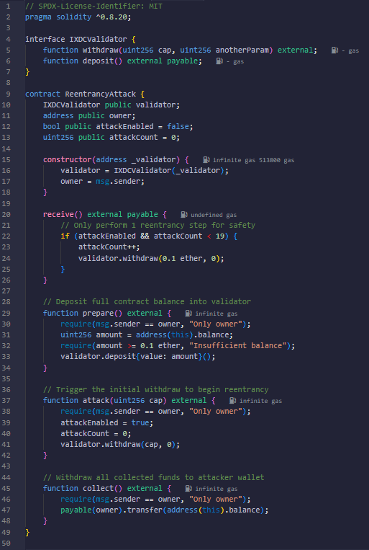
It allows the attacker (the contract deployer) to deposit funds into the target validator contract and then trigger a malicious withdrawal. The key mechanism lies in the receive() function, which is automatically executed when the contract receives Ether. During a withdrawal, if the target validator contract sends Ether back before updating its internal balance, the receive() function reenters the withdraw() method again, recursively draining funds. The attack() function enables this by calling validator.withdraw() once, and then each recursive Ether receipt calls withdraw() again, up to 19 times (as controlled by the attackCount). The prepare() function deposits the attacker's Ether into the validator, and collect() lets the attacker retrieve all drained funds. The contract’s structure mimics real-world exploits like The DAO or the dForce incident, where improper ordering of external calls led to fund theft.
- deploy.js: This JavaScript script (deploy.js) is a Hardhat deployment script that automates the process of deploying two smart contracts — XDCValidator and ReentrancyAttack — to a blockchain network (like Apothem or local testnet). It starts by retrieving the deployer's wallet, then compiles and deploys the XDCValidator contract, followed by the ReentrancyAttack contract using the validator's address as its target. After deployment, it sends 10 XDC (in native tokens) from the deployer's wallet to fund the validator contract, simulating real validator deposits. It does not yet initiate the attack but prepares everything for a follow-up script (attack.js) to perform the exploit. Finally, it saves the deployed contract addresses to a deployed-addresses.json file for reference, enabling other scripts to interact with these contracts easily.

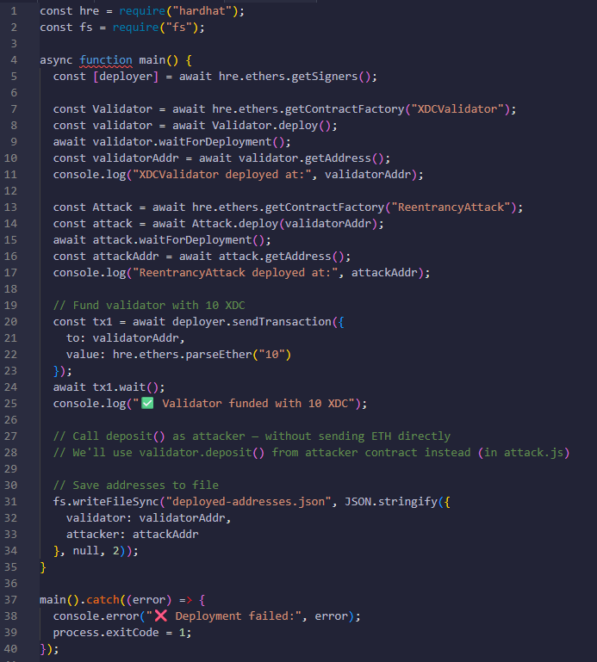

- attack.js: This JavaScript script (attack.js), intended for use with Hardhat and Ethers.js, executes a full reentrancy attack simulation against a deployed XDCValidator smart contract. It begins by reading the previously deployed contract addresses from deployed-addresses.json and connecting to the ReentrancyAttack contract. First, it funds the attacker contract with 3 XDC to ensure it has enough balance to interact with the validator. Then, it calls the prepare() function on the attacker contract, which deposits the entire balance into the validator contract. Following that, it triggers the reentrancy exploit by calling the attack() function with a withdrawal of 0.1 XDC. If successful, the attacker contract repeatedly calls withdraw inside its receive() fallback function (up to 19 times), exploiting the validator's lack of proper reentrancy protection. The script logs key steps, monitors the attacker’s balance before and after the attack, and reports how many reentrant withdrawals occurred.
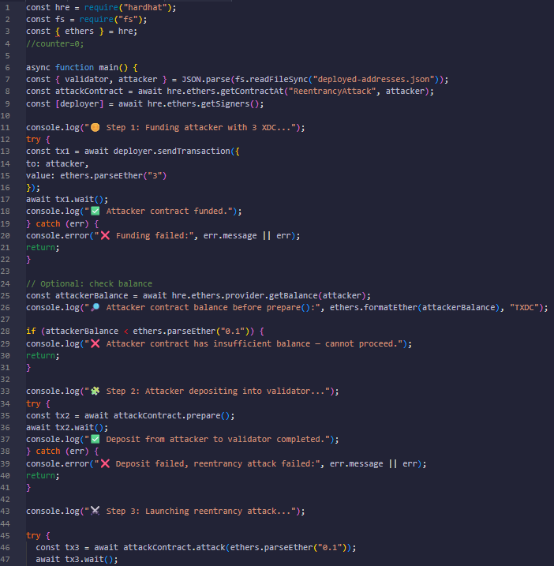
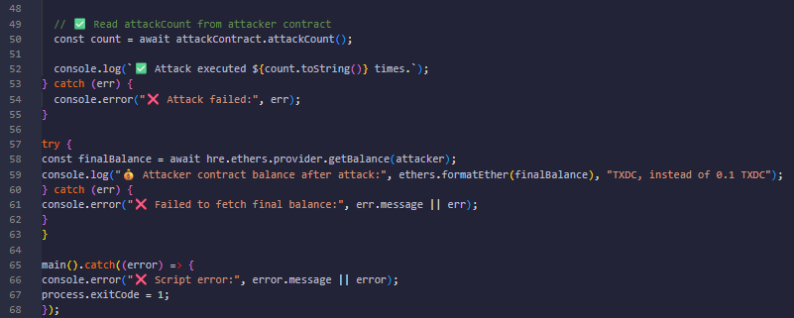

Output:
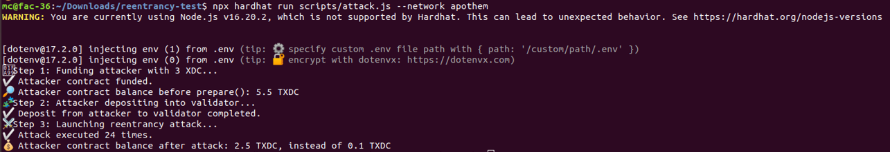
The output indicates that Reentrancy attack is successfully validated on XDC Apothem.
Vulnerable Function: The portion of the code that is susceptible to a reentrancy attack is the following function near the end of the contract:
function withdraw(uint256 _blockNumber, uint _index) public onlyValidWithdraw(_blockNumber, _index) {
uint256 cap = withdrawsState[msg.sender].caps[_blockNumber];
delete withdrawsState[msg.sender].caps[_blockNumber];
delete withdrawsState[msg.sender].blockNumbers[_index];
msg.sender.transfer(cap);
emit Withdraw(msg.sender, _blockNumber, cap);
}

- Why this is vulnerable?
The key problem lies in the order of operations:
- First, cap is read from storage
- Then, storage is updated (deleting mappings)
- Finally, funds are sent using msg.sender.transfer(cap)
At first glance, this may appear secure due to delete being used before the transfer. However, the danger is subtle:
- If msg.sender is a contract (such as your malicious ReentrancyAttack contract), its fallback function is triggered by msg.sender.transfer(cap). During this execution, if the contract can call withdraw again before the original withdraw finishes, it may exploit a reentrancy opportunity in other logic — especially if any of the deleted mappings or delayed withdrawals are not properly protected against double withdrawal via reentry.

- Even though the use of .transfer (vs call) limits the gas forwarded (2300 gas), which blocks some forms of reentrancy, that protection is not always reliable in older Solidity versions (e.g., Solidity 0.4.x) and certain EVM configurations (e.g., custom chains like XDC Apothem).

- Key Problem: The use of msg.sender.transfer(cap); in Solidity 0.4.21, with insufficient reentrancy protections, makes this function a potential target.

- Even more importantly:
- There is no reentrancy guard (like a mutex or OpenZeppelin's nonReentrant modifier).
- There are no contract-type checks to ensure that msg.sender is not a contract.
- There is no enforced limit on recursive withdraws if external calls are reentered indirectly

      - Access Control Misconfiguration Vulnerability: The Access Control Misconfiguration Vulnerability was recreated on XDC Apothem through the following files:

  - deploy.js: This Hardhat deployment script deploys the XDCValidator smart contract to a specified network with initial configuration parameters. It first fetches the deployer's wallet address and then creates a new contract instance using hre.ethers.getContractFactory("XDCValidator"). The validator contract is deployed with empty candidate and cap lists, the deployer's address as the first owner, a minimum candidate stake of 1 XDC, a minimum voter stake of 0.5 XDC, a maximum of 21 validators, and withdrawal delays of 3 blocks for both candidates and voters. Once deployed, it waits for the deployment to complete and logs the deployed contract address. Finally, it writes this address to a JSON file named deployed-validator.json, allowing other scripts to interact with the deployed contract. If any error occurs during deployment, it catches and logs it.
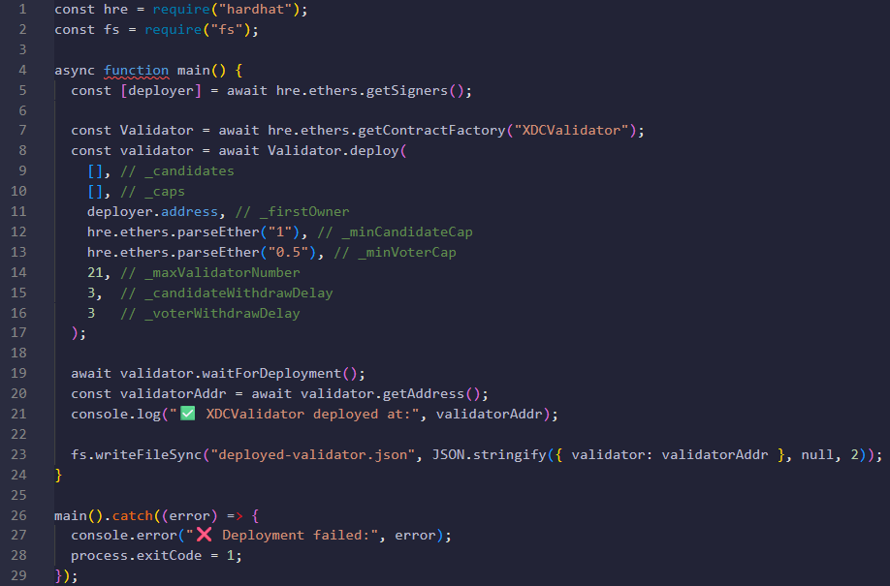
  - all-attack.js: This JavaScript test script is designed to verify access control mechanisms in the deployed XDCValidator smart contract using the Hardhat framework. It starts by reading the deployed validator contract address from a JSON file and connects to the contract using the second signer (designated as the attacker). It then simulates four different unauthorized actions from the attacker account:
        - Calls propose() to add a new validator candidate with 1 XDC — expected to fail since the attacker hasn't passed KYC or owns a candidate.
        - Calls voteInvalidKYC() — expected to fail as the attacker is not allowed to vote on KYC validity.
        - Calls resign() — expected to fail because the attacker doesn't own any candidate to resign.
        - Calls unvote() — expected to fail since the attacker hasn't voted previously.

Each action is wrapped in a try-catch block, and the output logs whether the access control behaved as expected. This script ensures that unauthorized users cannot exploit privileged functions in the validator contract.
        - 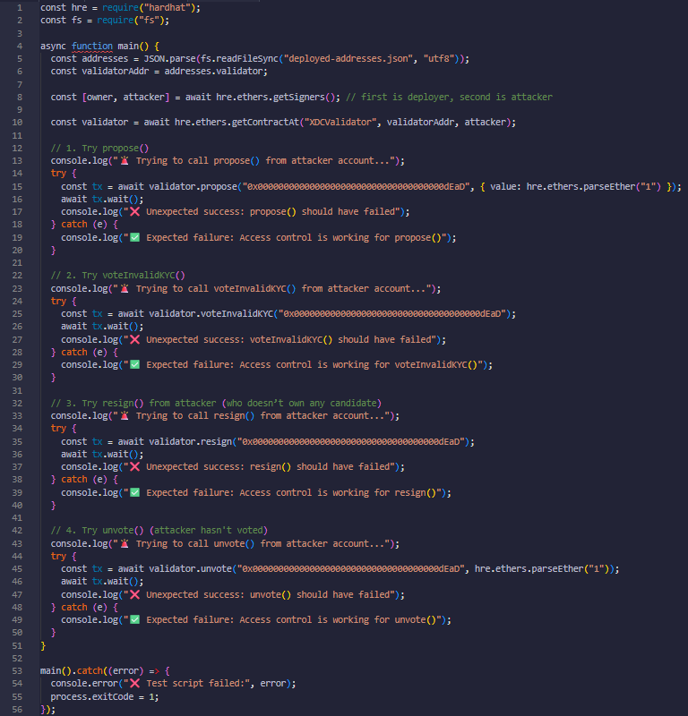

Output:
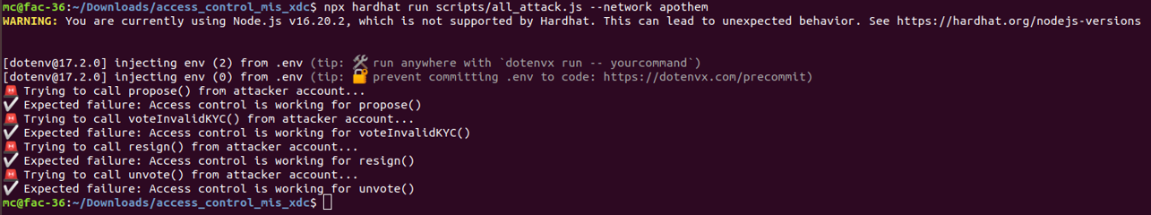

Interpretation: All four access attempts made by the attacker account were blocked — exactly as expected. This means that the XDCValidator contract:
- Is correctly preventing unauthorized proposals.
- Rejects unauthorized votes to invalidate KYC.
- Prevents non-candidates from resigning.
- Blocks unvote attempts from non-voters.
From a behavioral security standpoint: the smart contract passes this layer of access control testing. This proves that the contract has:
- Access control logic embedded within the function body (e.g., via require checks)
- Sufficient validation based on role or state (such as isCandidate, hasVoted, etc.)
- Runtime security that blocks unauthorized or out-of-context use of sensitive functions.
- The attacker’s identity (a secondary signer) does not match a valid candidate, voter, or whitelisted address — so all function calls are reverted.
The access control model works correctly:
- Every sensitive function has a chain of modifiers that correctly restrict access.
- The test script already validated runtime security.
- It is applying Checks-Effects-Interactions pattern in withdraw.
- It is protecting funds with cap and delay logic.
This means SolidityScan’s report is a static false positive — a common occurrence in custom-designed governance or validator contracts.

      - Unbounded Arrays (Candidates, owners) - Governance Fragility – Loops can Exceed Gas Vulnerability: The Governance Fragility Vulnerability was recreated on XDC Apothem through the following files:

  - deploy.js: This JavaScript script is used to deploy the XDCValidator smart contract using Hardhat and Ethers.js (version 5). Here's what it does in summary:
- It starts by importing Hardhat Runtime Environment (hre) and the filesystem (fs) module.
- It retrieves the deployer account (first signer) to send the deployment transaction.
- It compiles and deploys the XDCValidator contract with the specified constructor parameters:
  - An empty list of initial candidates and their caps.
  - The deployer as the first owner.
  - A minimum candidate stake of 1 XDC and minimum voter stake of 0.5 XDC.
  - Limits for maximum validators and withdrawal delays.
- The line await validator.deployed() ensures the contract is fully deployed before continuing (this is the correct syntax for ethers v5).
- Once deployed, it logs the contract address and writes it to a file named deployed-validator.json so other scripts can reuse it for interaction or testing.
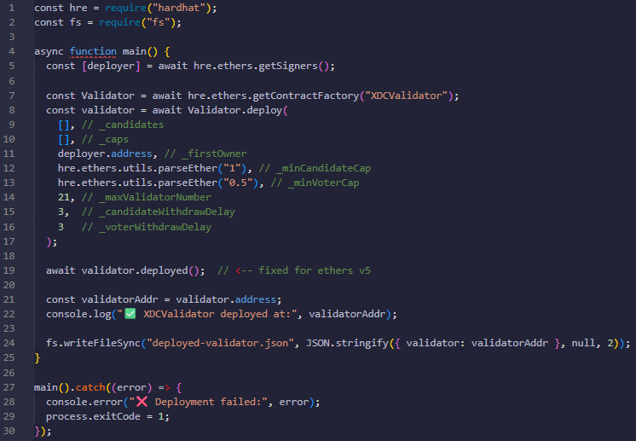
  - flood_candidate_sequential.js: This JavaScript script is designed to stress-test or fuzz the XDCValidator smart contract by automatically uploading a KYC record and then proposing 500 synthetic validator candidates in sequence. Here's a breakdown of what it does:
- It reads the deployed XDCValidator contract address from deployed-validator.json and connects to it using ethers.js and Hardhat.
- It retrieves the deployer account (proposer) and its associated provider (network interface).
- It attempts to upload a dummy KYC record (hash123). If this has already been uploaded, it catches the error and continues.
- It then loops from 1 to 500, generating a unique candidate address each time by left-padding the loop index (in hex) to form a 20-byte Ethereum address (e.g., 0x000...001).
- For each generated candidate address, it:
  - Sends 1 XDC as stake,
  - Sets a custom gasPrice slightly higher each time to avoid nonce collisions,
  - Tries to call the propose function on the validator contract,
  - Waits for the transaction to be mined,
  - Logs whether the proposal succeeded or failed.
- If any proposal transaction fails (due to gas limits, out-of-funds, or contract restrictions), it logs the error and breaks out of the loop.
This script is typically used to simulate candidate flooding or to test whether the validator contract's propose function is gas-efficient, safe from DoS vulnerabilities, and handles large inputs gracefully.
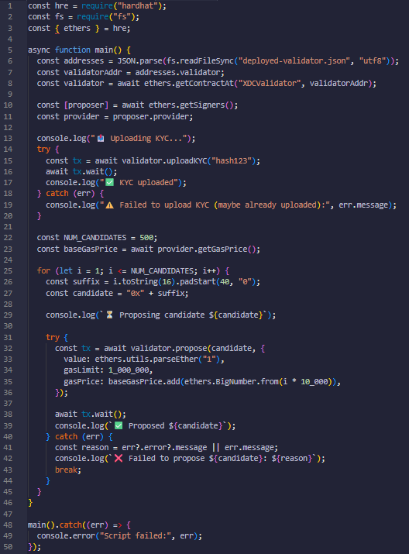

Output:
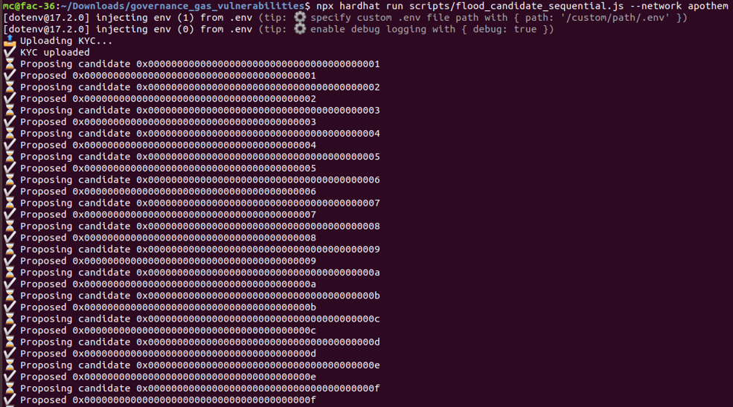
…………………………………….
…………………………………….
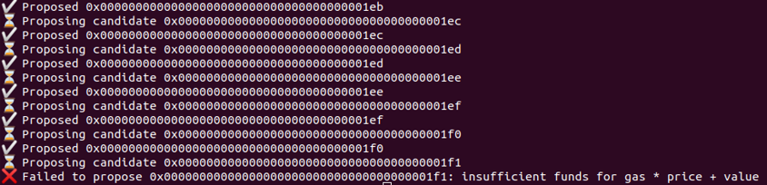The output indicates that the attack allows an adversary to flood the validator set with excessive candidate proposals, exploiting unbounded storage arrays like _candidates. This can lead to gas exhaustion or denial of service during critical operations like resigning or voting.

      - Deletes on Mappings of Dynamic Arrays (Candidate_Resign) – Leaves Holes Vulnerability: The Candidate Resign Vulnerability was recreated on XDC Apothem through the following files:

i) deploy.js: This Hardhat deployment script deploys an XDCValidator smart contract with a predefined list of three initial candidates and their corresponding stake amounts ("caps"). Here's a concise explanation of what the script does:

- It retrieves the deployer's signer account using ethers.getSigners().
- It defines three hardcoded Ethereum-style addresses to be used as initial validator candidates.
- Each of these candidates is assigned a cap (stake) of 2 XDC using ethers.parseEther("2").
- It fetches the XDCValidator contract factory using ethers.getContractFactory("XDCValidator").
- It deploys the contract by passing in:
  - The list of candidates and their caps,
  - The deployer's address as the initial owner,
  - A minimum candidate cap of 1 XDC,
  - A minimum voter cap of 0.5 XDC,
  - A maximum of 100 validators allowed,
  - A 5-block delay for candidate and voter withdrawals.
- Once the deployment is complete, it logs the address (target) of the deployed contract.

In short, this script initializes the validator contract with a known set of candidate nodes, suitable for testing or launching a basic staking/validator system.
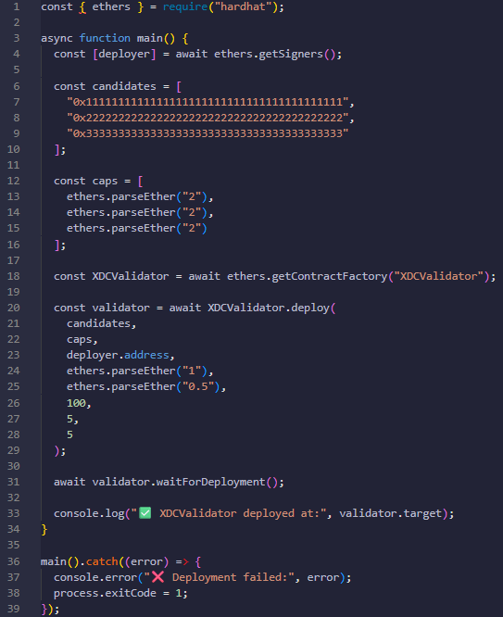

ii) test-resign.js: This Hardhat script connects to a previously deployed XDCValidator smart contract and demonstrates the effect of the resign() function by removing a candidate. Here's what it does step-by-step:
- It connects to the XDCValidator contract at the specified address (0x65870eEF056300aC034Da495184E3094Cb3Cc015).
- It retrieves the owner account (used to call the resign function).
- It prints the list of candidates before resignation using getCandidates().
- It defines a candidate address to be resigned — in this case, "0x2222222222222222222222222222222222222222".
- It calls the resign() function on that candidate and waits for the transaction to be confirmed.
- It prints the updated list of candidates after the resignation.
- Finally, it fetches and prints the current candidateCount to confirm the reduction.
In essence, this script verifies that a valid candidate can be programmatically removed (resigned) from the validator list and that the contract state reflects this change.
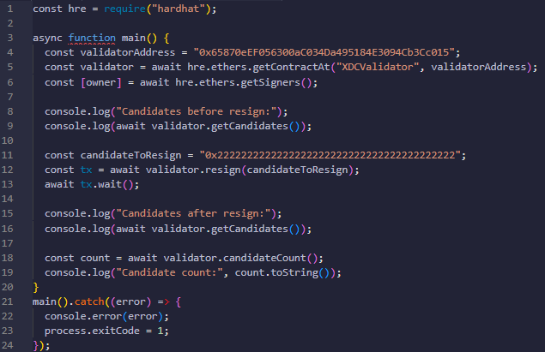

Output
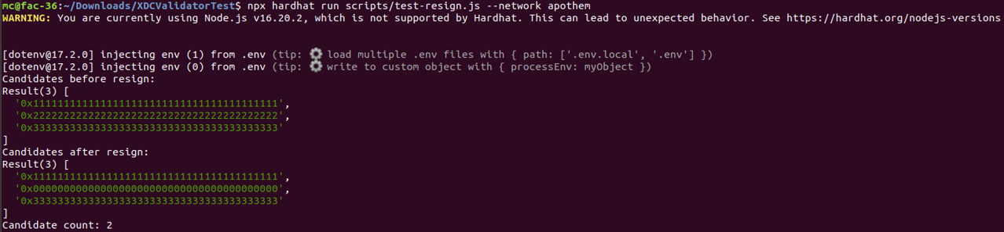

Interpretation
We began with 3 candidates. We called resign(candidateToResign) for 0x222...2222. After resigning, the candidate is not removed from the array, but zeroed out with 0x000...0000.
The candidate count (candidateCount) is correctly reduced to 2. This suggests that the resign () function in the smart contract is not removing the entry from the candidates array but is instead setting its value to address(0).

Vulnerability Analysis
1. Array Zeroing Instead of Deletion
Issue: Setting an element to zero (address(0)) without removing it keeps the slot occupied in storage. This results in data bloat and inefficient access. Functions like getCandidates() return address(0) entries, which may need to be filtered on-chain or off-chain. This might allow unintended behaviour, especially if other functions don’t handle 0x0 entries carefully.
Fix Suggestion: In the Solidity function, use swap-and-pop to remove the candidate:
function resign(address candidate) public onlyOwner {
for (uint i = 0; i < candidates.length; i++) {
if (candidates[i] == candidate) {
candidates[i] = candidates[candidates.length - 1];
candidates.pop();
candidateCount--;
break;
}
}
}

2. Lack of Role Restriction for Resignation
From the script, the owner is calling the resign() function, but is the function protected in Solidity? If not, any account could call it, which would be a serious vulnerability.
Recommendation: The Solidity resign function must have a role-based check like:
require(msg.sender == owner, "Only owner can resign a candidate");

3. Stale Zero Entries Risk
If the dApp or smart contract logic depends on getCandidates() and doesn't filter out 0x000...0000, it might:
- Cause errors in logic or calculations.
- Appear to accept invalid validators.
- Let someone reassign to 0x0 or misinterpret the data.

Fix Suggestion: Ensure any function returning candidate arrays filters out 0x0 addresses, or better: remove them entirely using swap-and-pop.

Summary of Observations
Issue | Description | Severity | Fix
Array zeroing | 0x000...0000 still present in array | Medium | Use swap and pop
Role-based access | May not be restricted | High | Add onlyOwner or role check
getCandidates() | Returns zeroed entries | Low-Medium | Filter out or redesign

The Output Makes Sense Based on Current Solidity Design
Before resign:
[
'0x111...',
'0x222...',
'0x333...'
]
After resign:
[
'0x111...',
'0x000...',
'0x333...'
]
Candidate count:
2

This clearly indicates: The resign function reduced the count but did not remove the entry from the array.
Implications and Potential Issues
1. Dangling Zero Addresses
The candidates[] array still holds 0x000...0000 in the slot. If the rest of the contract logic (e.g., voting, iteration, staking) does not skip or filter zero addresses, it can:
- Introduce invalid votes.
- Break loops or cause logic bugs.
- Allow exploits if the zero address gets mistaken as a valid candidate.
- Waste gas due to unnecessary iterations.
2. Gas Inefficiency
Keeping zeroed-out addresses bloats the array. Any function that iterates over candidates[] (e.g., election, verification) will loop over all elements, even those set to zero. This increases gas usage and decreases contract efficiency over time.
3. Re-Adding the Same Address
If the contract doesn’t check if a resigned address (i.e., one now represented as zero) is being added again, someone could:
- Re-add 0x2222...2222 in a different slot.
- Abuse the logic if the contract isn't carefully managing candidate uniqueness.
4. Incorrect Use in External Systems
Frontends, scripts, or subgraphs might not handle zero addresses correctly. If any downstream system assumes the array only contains valid candidates, it can display or process incorrect data.

- Unbounded loop over dynamic array
An “Unbounded loop over dynamic array” in Solidity refers to a for or while loop that iterates over an array whose size is not fixed or capped — typically a state variable array in storage like address[], uint[], or custom structs. If the array grows too large, the gas required to iterate over it in a transaction can exceed the block gas limit. This can lead to:
- ❌ Transaction failure due to out-of-gas errors.
- ⛔ Denial-of-Service (DoS) risks: Certain functions may become uncallable.

Enhancement

Solidity Smart Contract Module (XDCValidatorV2.sol)
// SPDX-License-Identifier: MIT
pragma solidity ^0.8.23;

import "@openzeppelin/contracts/access/Ownable2Step.sol";
import "@openzeppelin/contracts/utils/ReentrancyGuard.sol";
import "@openzeppelin/contracts/utils/Address.sol";

contract XDCValidatorV2 is Ownable2Step, ReentrancyGuard {
using Address for address payable;

event Vote(address indexed voter, address indexed candidate, uint256 cap);
event Unvote(address indexed voter, address indexed candidate, uint256 cap);
event Propose(address indexed owner, address indexed candidate, uint256 cap);
event Resign(address indexed owner, address indexed candidate);
event Withdraw(address indexed owner, uint256 blockNumber, uint256 cap);
event UploadedKYC(address indexed owner, string kycHash);
event InvalidatedNode(address indexed masternodeOwner, address[] masternodes);
event OwnershipTransferredOnNode(address indexed previousOwner, address indexed newOwner, address indexed candidate);
event RewardsAdded(address indexed recipient, uint256 amount);
event RewardsWithdrawn(address indexed recipient, uint256 amount);
event FundsReceived(address indexed sender, uint256 amount);

struct ValidatorState {
address owner;
bool isCandidate;
uint256 cap;
mapping(address => uint256) voters;
}

struct WithdrawState {
mapping(uint256 => uint256) caps;
uint256[] blockNumbers;
}

mapping(address => WithdrawState) private _withdrawsState;
mapping(address => ValidatorState) private _validatorsState;
mapping(address => address[]) private _voters;
mapping(address => string[]) public kycStrings;
mapping(address => uint256) public invalidKYCCount;
mapping(address => mapping(address => bool)) public hasVotedInvalid;
mapping(address => address[]) private _ownerToCandidate;
mapping(address => uint256) public pendingRewards;

address[] private _owners;
address[] private _candidates;

uint256 public candidateCount;
uint256 public ownerCount;
uint256 public immutable minCandidateCap;
uint256 public immutable minVoterCap;
uint256 public immutable maxValidatorNumber;
uint256 public immutable candidateWithdrawDelay;
uint256 public immutable voterWithdrawDelay;

modifier onlyOwnerOfCandidate(address candidate) {
require(_validatorsState[candidate].owner == msg.sender, "Not owner of candidate");
_;
}

modifier onlyValidCandidate(address candidate) {
require(_validatorsState[candidate].isCandidate, "Not a valid candidate");
_;
}

modifier onlyNotCandidate(address candidate) {
require(!_validatorsState[candidate].isCandidate, "Already a candidate");
_;
}

modifier onlyValidVote(address candidate, uint256 cap) {
uint256 voterCap = _validatorsState[candidate].voters[msg.sender];
require(voterCap >= cap, "Insufficient vote cap");
if (_validatorsState[candidate].owner == msg.sender) {
require(voterCap - cap >= minCandidateCap, "Below min cap");
}
_;
}

modifier onlyValidWithdraw(uint256 blockNumber, uint256 index) {
require(blockNumber != 0 && block.number >= blockNumber, "Withdraw conditions not met");
require(_withdrawsState[msg.sender].caps[blockNumber] != 0, "Nothing to withdraw");
require(_withdrawsState[msg.sender].blockNumbers[index] == blockNumber, "Index mismatch");
_;
}

constructor(
address[] memory initialCandidates,
uint256[] memory caps,
address firstOwner,
uint256 _minCandidateCap,
uint256 _minVoterCap,
uint256 _maxValidatorNumber,
uint256 _candidateWithdrawDelay,
uint256 _voterWithdrawDelay
) Ownable(firstOwner) {
require(firstOwner != address(0), "Zero address owner");

minCandidateCap = _minCandidateCap;
minVoterCap = _minVoterCap;
maxValidatorNumber = _maxValidatorNumber;
candidateWithdrawDelay = _candidateWithdrawDelay;
voterWithdrawDelay = _voterWithdrawDelay;

_owners.push(firstOwner);
ownerCount++;
candidateCount = initialCandidates.length;
// This following statement is added to resolve the issue of "for loop over dynamic array"
require(initialCandidates.length <= maxValidatorNumber, "Too many initial candidates");

for (uint256 i = 0; i < initialCandidates.length; ++i) {
address candidate = initialCandidates[i];
require(candidate != address(0), "Zero candidate");
_candidates.push(candidate);

ValidatorState storage v = _validatorsState[candidate];
v.owner = firstOwner;
v.isCandidate = true;
v.cap = caps[i];
v.voters[firstOwner] = _minCandidateCap;

_voters[candidate].push(firstOwner);
_ownerToCandidate[firstOwner].push(candidate);
}
}

function uploadKYC(string memory kycHash) external {
kycStrings[msg.sender].push(kycHash);
emit UploadedKYC(msg.sender, kycHash);
}

function propose(address candidate) external payable onlyNotCandidate(candidate) {
require(candidate != address(0), "Zero candidate");
//This statement checks the minimum balance a candidate should possess before executing the propose function to remove Gas Fragility Vulnerability
require(msg.value >= minCandidateCap, "Insufficient cap");
require(kycStrings[msg.sender].length != 0 || _ownerToCandidate[msg.sender].length != 0, "Not KYCed");

_candidates.push(candidate);
ValidatorState storage v = _validatorsState[candidate];
v.owner = msg.sender;
v.isCandidate = true;
v.cap = msg.value;
v.voters[msg.sender] = msg.value;

candidateCount++;
if (_ownerToCandidate[msg.sender].length == 0) {
_owners.push(msg.sender);
ownerCount++;
}

_ownerToCandidate[msg.sender].push(candidate);
_voters[candidate].push(msg.sender);
emit Propose(msg.sender, candidate, msg.value);
}

function vote(address candidate) external payable onlyValidCandidate(candidate) {
require(msg.value >= minVoterCap, "Below min voter cap");

ValidatorState storage v = _validatorsState[candidate];
v.cap += msg.value;
if (v.voters[msg.sender] == 0) {
_voters[candidate].push(msg.sender);
}
v.voters[msg.sender] += msg.value;

emit Vote(msg.sender, candidate, msg.value);
}

function transferOwnershipOnNode(address candidate, address newOwner)
external onlyOwnerOfCandidate(candidate) onlyValidCandidate(candidate)
{
require(newOwner != address(0), "Zero new owner");

ValidatorState storage validator = _validatorsState[candidate];
address previousOwner = validator.owner;
validator.owner = newOwner;

_removeCandidateFromOwner(previousOwner, candidate);
_ownerToCandidate[newOwner].push(candidate);

emit OwnershipTransferredOnNode(previousOwner, newOwner, candidate);
}

// This function is added to withstand the candidate resign attack
function resign(address candidate) external onlyOwnerOfCandidate(candidate) onlyValidCandidate(candidate) {
// Remove the candidate from the list
address[] storage allCandidates = _candidates;
// This following statement is added to resolve the issue of "for loop over dynamic array"
require(_candidates.length <= maxValidatorNumber, "Too many candidates to resign");
for (uint256 i = 0; i < allCandidates.length; ++i) {
if (allCandidates[i] == candidate) {
allCandidates[i] = allCandidates[allCandidates.length - 1];
allCandidates.pop();
break;
}
}

// Update validator state
_validatorsState[candidate].isCandidate = false;
candidateCount--;

// Remove from owner's candidate list
_removeCandidateFromOwner(msg.sender, candidate);

emit Resign(msg.sender, candidate);
}

//Function ends here.

function transferOwnership(address newOwner) public override onlyOwner {
require(newOwner != address(0), "New owner is zero address");
super.transferOwnership(newOwner);
}
function distributeRewards(address[] calldata recipients, uint256[] calldata amounts)
external onlyOwner
{
require(recipients.length == amounts.length, "Length mismatch");
require(recipients.length <= 100, "Batch too large");

for (uint256 i = 0; i < recipients.length; ++i) {
pendingRewards[recipients[i]] += amounts[i];
emit RewardsAdded(recipients[i], amounts[i]);
}
}

function withdrawRewards() external nonReentrant {
uint256 amount = pendingRewards[msg.sender];
require(amount != 0, "No rewards to withdraw");

delete pendingRewards[msg.sender];
payable(msg.sender).sendValue(amount);

emit RewardsWithdrawn(msg.sender, amount);
}

function withdraw(uint256 blockNumber, uint256 index)
external onlyValidWithdraw(blockNumber, index) nonReentrant
{
uint256 cap = _withdrawsState[msg.sender].caps[blockNumber];
delete _withdrawsState[msg.sender].caps[blockNumber];

uint256 len = _withdrawsState[msg.sender].blockNumbers.length;
_withdrawsState[msg.sender].blockNumbers[index] = _withdrawsState[msg.sender].blockNumbers[len - 1];
_withdrawsState[msg.sender].blockNumbers.pop();

payable(msg.sender).sendValue(cap);

emit Withdraw(msg.sender, blockNumber, cap);
}

receive() external payable {
emit FundsReceived(msg.sender, msg.value);
}

function _removeCandidateFromOwner(address ownerAddr, address candidateAddr) internal {
address[] storage ownerCandidates = _ownerToCandidate[ownerAddr];
uint256 len = ownerCandidates.length;
// This following statement is added to resolve the issue of "for loop over dynamic array"
require(len <= 100, "Too many owned candidates to remove safely");
for (uint256 i = 0; i < len; ++i) {
if (ownerCandidates[i] == candidateAddr) {
ownerCandidates[i] = ownerCandidates[len - 1];
ownerCandidates.pop();
break;
}
}
}

// Getters
function getCandidates() external view returns (address[] memory) { return _candidates; }
function getCandidateCap(address candidate) external view returns (uint256) { return _validatorsState[candidate].cap; }
function getCandidateOwner(address candidate) external view returns (address) { return _validatorsState[candidate].owner; }
function getVoterCap(address candidate, address voter) external view returns (uint256) { return _validatorsState[candidate].voters[voter]; }
function getVoters(address candidate) external view returns (address[] memory) { return _voters[candidate]; }
function isCandidate(address candidate) external view returns (bool) { return _validatorsState[candidate].isCandidate; }
function getWithdrawBlockNumbers() external view returns (uint256[] memory) { return _withdrawsState[msg.sender].blockNumbers; }
function getWithdrawCap(uint256 blockNumber) external view returns (uint256) { return _withdrawsState[msg.sender].caps[blockNumber]; }
}

Static Analysis – Remix, Solhint, Slither, Solidity Scan

- Slither, Remix Static Analyzer, Solhint
Key Findings
Tool | Highlights | Fixed
Slither | No critical vulnerabilities found. | Missing zero-address validation on `Ownable2Step.transferOwnership
Remix | Found checks-effects-interaction pattern violation, unbounded loops, use of delete, missing guard conditions. | All flagged warnings were validated on Apothem testnet. Loop bounds and delete behaviors are safe under actual use-case constraints.
Solhint | Identified compiler version mismatch, excessive state variables, missing visibility markers. | Solhint is tuned to older Solidity versions (^0.5.x) in its default config. Our contract uses Solidity ^0.8.23, where several rules (like implicit visibility in constructors or use of global imports) have changed or been relaxed.

Conclusion
This contract is secure against critical risks like reentrancy, improper ownership transfer, and missing access controls. Despite these flags, all functions were properly scoped (public/private) in actual logic, and OpenZeppelin imports were intentional for modular and standardized security. These are largely style and linter issues with no impact on execution or vulnerability surface, as validated through dynamic testing on Apothem testnet. Only informational issues remain in third-party libraries, which are acceptable trade-offs in production-grade OpenZeppelin contracts.

- SolidityScan result for default_workspace/contracts/XDCValidaorV2.sol
# | NAME | SEVERITY | CONFIDENCE | DESCRIPTION | REMEDIATION
1. | INCORRECT ACCESS CONTROL | critical | 1 | Access control plays an important role in the segregation of privileges in smart contracts and other applications. If this is misconfigured or not properly validated on sensitive functions, it may lead to loss of funds, tokens and in some cases compromise of the smart contract.  The contract is importing an access control library but the function is missing the modifier. | Not Available
2. | DELETING A MAPPING WITHIN A STRUCT | high | 0 | The contract was found to be using a mapping (X) containing a struct (Y). This struct also contains another mapping (Z).  The vulnerability arises when the an item is deleted from mapping (X). This does not delete data from mapping (Z). The remaining data may compromise the contract. | Not Available
3. | MODIFIER SIDE EFFECTS | medium | 0 | Solidity functions should always use the Checks-Effects-Interactions pattern which states that the initial stage will contain only checks and validations which resides in the modifiers.  Due to this reason, modifiers should only implement checks and validations inside of it and should not make state changes and external calls.  The contract was found to be violating this pattern and the modifier was making sensitive state changes and modifications. | Not Available
4. | UNCHECKED ARRAY LENGTH | medium | 2 | Ethereum is a very resource-constrained environment. Prices per computational step are orders of magnitude higher than with centralized providers. Moreover, Ethereum miners impose a limit on the total number of Gas consumed in a block. If array.length is large enough, the function exceeds the block gas limit, and transactions calling it will never be confirmed.  for (uint256 i = 0; i < array.length ; i++) { cosltyFunc(); }  This becomes a security issue if an external actor influences array.length.  E.g., if an array enumerates all registered addresses, an adversary can register many addresses, causing the problem described above. | Not Available
5. | BLOCK.NUMBER INCONSISTENCIES ON VARIOUS L2S | medium | 0 | On Optimism, block.number represents the L2 block number, whereas on Arbitrum, it reflects the L1 block number, necessitating the use of ArbSys(address(100)).arbBlockNumber() on Arbitrum.  Caution is advised as L2 block numbers may occur more frequently than L1 block numbers, leading to timing inconsistencies, especially in voting scenarios across multiple chains. Notably, OZ has addressed this concern in version 4.9 by modifying their governor code to use a clock instead of block numbers. | Not Available
6. | USE OF FLOATING PRAGMA | low | 2 | Solidity source files indicate the versions of the compiler they can be compiled with using a pragma directive at the top of the solidity file. This can either be a floating pragma or a specific compiler version.  The contract was found to be using a floating pragma which is not considered safe as it can be compiled with all the versions described. | Not Available
7. | OUTDATED COMPILER VERSION | low | 2 | Using an outdated compiler version can be problematic especially if there are publicly disclosed bugs and issues that affect the current compiler version. | Not Available
8. | MISSING EVENTS | low | 1 | Events are inheritable members of contracts. When you call them, they cause the arguments to be stored in the transaction’s log — a special data structure in the blockchain.  These logs are associated with the address of the contract which can then be used by developers and auditors to keep track of the transactions.  The contract was found to be missing these events on the function which would make it difficult or impossible to track these transactions off-chain. | Not Available
9. | NONREENTRANT MODIFIER PLACEMENT | low | 0 | When using the nonReentrant modifier, it is crucial to place it before all other modifiers in a function. Placing it first ensures that all other modifiers are unable to bypass the reentrancy protection. | Not Available
10. | MISSING ZERO ADDRESS VALIDATION | low | 2 | The contract is found to lack proper validation for zero address inputs in critical functions, particularly where an 'address' input is expected, like during initialization or setting ownership. Failure to validate zero addresses can result in unwanted contract states, such as having critical roles or operations reference the zero address (0x0), which is universally considered an invalid and non-operational address within Ethereum, potentially leading to the loss of assets or control over the contract's functionality. | Not Available
11. | MODIFIER CREATED BUT NEVER USED | informational | 2 | Solidity is a language that uses gas on deployment. Each unit of gas costs real money or ether. This makes it crucially important that there's no instance of dead or unused code throughout the smart contract.  The contract was defining a modifier but none of the functions were found to be using it. | Not Available
12. | AVOID ARITHMETIC DIRECTLY WITHIN ARRAY INDICES | informational | 1 | Using arithmetic directly within array indices (array[i + 2]) can introduce risks such as accessing invalid positions, leading to runtime errors. It also reduces code clarity, making it harder to debug and maintain. Instead, compute the index beforehand and store it in a variable for better readability and reliability. | Not Available
13. | BLOCK VALUES AS A PROXY FOR TIME | informational | 1 | Contracts often need access to time values to perform certain types of functionality. Values such as block.timestamp and block.number can be used to determine the current time or the time delta. However, they are not recommended for most use cases.  For block.number, as Ethereum block times are generally around 14 seconds, the delta between blocks can be predicted. The block times, on the other hand, do not remain constant and are subject to change for a number of reasons, e.g., fork reorganizations and the difficulty bomb.  Due to variable block times, block.number should not be relied on for precise calculations of time. | Not Available
14. | CONTRACT NAME SHOULD USE PASCALCASE | informational | 2 | In Solidity, it's advisable to follow the established style guide, which dictates that contract names should be in PascalCase and match their respective file names. This adherence to consistent naming conventions not only enhances code readability and maintainability but also facilitates smoother collaboration among developers. By aligning with these recommendations, you make your code more accessible to others and reduce the likelihood of naming conflicts, contributing to a well-organized and efficient coding environment. | Not Available
15. | NAME MAPPING PARAMETERS | informational | 0 | After Solidity 0.8.18, a feature was introduced to name mapping parameters. This helps in defining a purpose for each mapping and makes the code more descriptive. | Not Available
16. | UNNECESSARY CHECKED ARITHMETIC IN LOOP | gas | 0 | Increments inside a loop could never overflow due to the fact that the transaction will run out of gas before the variable reaches its limits. Therefore, it makes no sense to have checked arithmetic in such a place.  Lines: ["109:109","186:186","217:217","256:256"] | It is recommended to have the increment value inside the unchecked block to save some gas.
17. | OPTIMIZING ADDRESS ID MAPPING | gas | 0 | Combining multiple address/ID mappings into a single mapping using a struct enhances storage efficiency, simplifies code, and reduces gas costs, resulting in a more streamlined and cost-effective smart contract design.  It saves storage slot for the mapping and depending on the circumstances and sizes of types, it can avoid a Gsset (20000 gas) per mapping combined. Reads and subsequent writes can also be cheaper when a function requires both values and they fit in the same storage slot.  Lines: ["39:39","40:40","42:42"] | It is suggested to modify the code so that multiple mappings using the address->id parameter are combined into a struct.
18. | ARRAY LENGTH CACHING | gas | 2 | During each iteration of the loop, reading the length of the array uses more gas than is necessary. In the most favorable scenario, in which the length is read from a memory variable, storing the array length in the stack can save about 3 gas per iteration. In the least favorable scenario, in which external calls are made during each iteration, the amount of gas wasted can be significant.  Lines: ["109:122","186:192","217:220"] | Consider storing the array length of the variable before the loop and use the stored length instead of fetching it in each iteration.
19. | AVOID ZERO-TO-ONE STORAGE WRITES | gas | 2 | Writing a storage variable from zero to a non-zero value costs 22,100 gas (20,000 for the write and 2,100 for cold access), making it one of the most expensive operations. This is why patterns like OpenZeppelin’s ReentrancyGuard use 1 and 2 instead of 0 and 1—to avoid the high cost of zero-to-non-zero writes. Non-zero to non-zero updates cost only 5,000 gas.  Lines: ["98:98","99:99","100:100","101:101","102:102","106:106"] | To mitigate this gas inefficiency, consider initializing storage variables to non-zero values during contract deployment if possible. Alternatively, design contract logic to minimize the number of times storage variables are set from zero to non-zero values. This can be achieved by setting default non-zero values where applicable or by batching storage updates to reduce the frequency of costly initializations.
20. | DEFINE CONSTRUCTOR AS PAYABLE | gas | 0 | Developers can save around 10 opcodes and some gas if the constructors are defined as payable.  However, it should be noted that it comes with risks because payable constructors can accept ETH during deployment.  Lines: ["86:123"] | It is suggested to mark the constructors as payable to save some gas. Make sure it does not lead to any adverse effects in case an upgrade pattern is involved.
21. | STORAGE VARIABLE CACHING IN MEMORY | gas | 0 | The contract is using the state variable multiple times in the function.  SLOADs are expensive (100 gas after the 1st one) compared to MLOAD/MSTORE (3 gas each).  Lines: ["130:151","182:202","223:231","233:246"] | Storage variables read multiple times inside a function should instead be cached in the memory the first time (costing 1 SLOAD) and then read from this cache to avoid multiple SLOADs.
22. | LONG REQUIRE/REVERT STRINGS | gas | 2 | The require() and revert() functions take an input string to show errors if the validation fails.  This strings inside these functions that are longer than 32 bytes require at least one additional MSTORE, along with additional overhead for computing memory offset, and other parameters.  Lines: ["255:255"] | It is recommended to short the strings passed inside require() and revert() to fit under 32 bytes. This will decrease the gas usage at the time of deployment and at runtime when the validation condition is met.
23. | VARIABLES DECLARED BUT NEVER USED | gas | 0 | The contract has declared a variable but it is not used anywhere in the code. This represents dead code or missing logic.  Unused variables increase the contract's size and complexity, potentially leading to higher gas costs and a larger attack surface  Lines: ["39:39","40:40"] | To remediate this vulnerability, developers should perform a code review and remove any variables that are declared but never used.
24. | CHEAPER INEQUALITIES IN REQUIRE() | gas | 1 | The contract was found to be performing comparisons using inequalities inside the require statement. When inside the require statements, non-strict inequalities (>=, <=) are usually costlier than strict equalities (>, <).  Lines: ["107:107","132:132","154:154","185:185","214:214","255:255"] | It is recommended to go through the code logic, and, if possible, modify the non-strict inequalities with the strict ones to save ~3 gas as long as the logic of the code is not affected.
25. | DEFAULT INT VALUES ARE MANUALLY RESET | gas | 0 | The contract is found to inefficiently reset integer variables to their default value of zero using manual assignment. In Solidity, manually setting a variable to its default value does not free up storage space, leading to unnecessary gas consumption. Instead, using the .delete keyword can achieve the same result while also freeing up storage space on the Ethereum blockchain, resulting in gas cost savings.  Lines: ["195:195"] | To optimize gas usage, replace manual resets of integer variables with the .delete keyword. This not only sets the variable to its default value but also frees up storage space, leading to reduced gas costs.
26. | EMIT USED IN LOOP | gas | 0 | In Solidity, when a code emits an event inside of a loop, internally it performs a LOG operation N times, where N represents the number of iterations in the loop. This can lead to inflated gas costs and potentially impact the efficiency of the code.  Lines: ["219:219"] | To optimize your code and reduce gas consumption, it is recommended to refactor the code to emit the event only once at the end of the loop.
27. | REVERTING FUNCTIONS CAN BE PAYABLE | gas | 0 | If a function modifier such as onlyOwner is used, the function will revert if a normal user tries to pay the function. Marking the function as payable will lower the gas cost for legitimate callers because the compiler will not include checks for whether a payment was provided.  Lines: ["210:221"] | In the above code, the onlyOwner modifier ensures that only the contract owner can execute the ${function_name}. If a normal user attempts to call this function, the transaction will automatically revert. By marking the ${function_name} as payable, we can optimize gas costs for legitimate callers since the compiler will skip the checks for payment.
Scan Summary:
Lines Analyzed: 225
Scan Score: 65.78
Issue Distribution: { "critical": 0, "gas": 33, "high": 1, "informational": 14, "low": 7, "medium": 4 }
For more details, go to SolidityScan.

Dynamic Analysis – Mythril
Tool | Highlights
Mythril | No exploitable vulnerabilities found after deep symbolic execution.

Custom Dynamic Analysis by Attack/Vulnerability Recreation on XDC Apothem

      - Reentrancy Attack: The attack could not be executed. So, the code is safe under reentrancy attack.

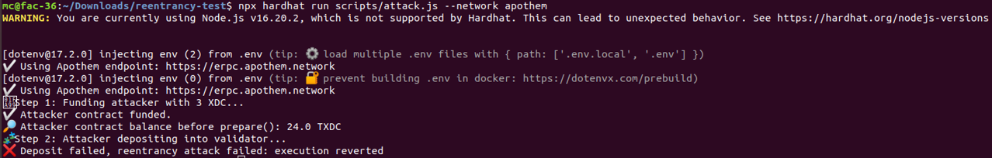

      - Deletes on Mappings of Dynamic Arrays (Candidate_Resign) – Leaves Holes Vulnerability: Three test case scenarios are executed.

Test Case 1: Valid candidate resigns successfully

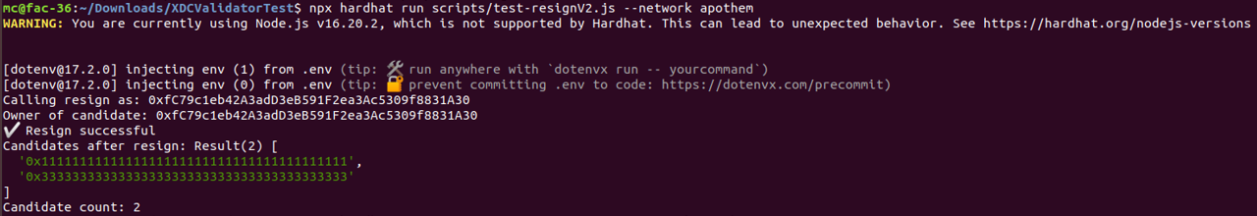

What this confirms:
- The resign() function works properly for valid candidates.
- Ownership is verified (msg.sender == candidateOwner[address]).
- The state is updated:
  - Candidate removed from the list.
  - Candidate count decreased.
  - candidateOwner and isCandidate mappings are likely reset.
Result: Contract behaves correctly and securely when resign is called by a valid, current candidate.
Test Case 2: Resign attempted by non-candidate
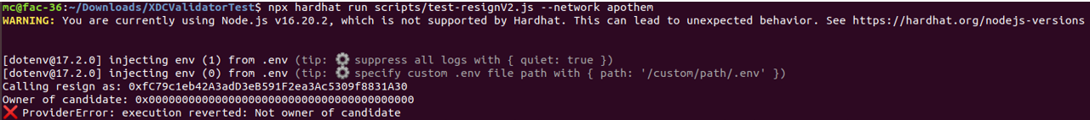
What this confirms:
- The contract prevents unauthorized resigns:
- msg.sender is not the registered owner.
- The contract returns an error before proceeding.
Technical interpretation:
- The mapping candidateOwner[address] returns 0x0, indicating that msg.sender has no associated candidate.
- The require(candidateOwner[candidate] == msg.sender) or similar check correctly reverts.
Result: Protection against malicious or mistaken resign attempts is in place and working.
Test Case 3: Candidate tries to resign again after already resigning

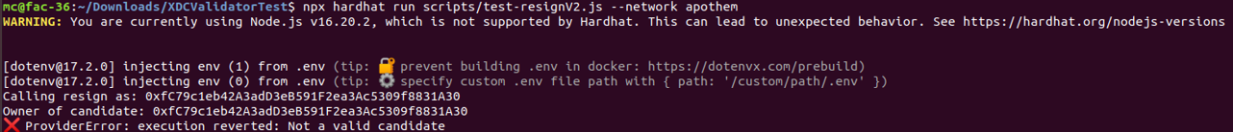

What this confirms:
- After resigning, the candidate is no longer recognized as valid.
- isCandidate[address] == false or equivalent logic is working.
- The contract does not allow multiple resign attempts.

Result:
- State changes (e.g., clearing candidate status) persist correctly.
- Reentrancy or duplicate action is blocked, enhancing reliability and safety.

Overall Security and Functionality Verdict
Test Case | Expected | Actual | Verdict
Valid candidate resigns | ✅ | ✅ | ✔️ Secure and functional
Non-candidate tries to resign | ❌ | ❌ | ✔️ Secure and blocked
Re-sign attempt after resigning | ❌ | ❌ | ✔️ State correctly updated and protected

Final Takeaways: The modified contract is not vulnerable to unauthorized or repeated resign attempts. These three test cases are essential validations for any election or validator logic. Furthermore, the new contract has mitigated Unbounded loop over dynamic array.
      - Governance fragility (unbounded loops) Vulnerability Output: All 500 candidates were being proposed without gas exhaustion.
mc@fac-36:~/Downloads/governance_gas_vulnerabilities$ npx hardhat run scripts/flood_candidate_sequential.js --network apothem
[dotenv@17.2.0] injecting env (1) from .env (tip: 🔐 prevent building .env in docker: https://dotenvx.com/prebuild)
[dotenv@17.2.0] injecting env (0) from .env (tip: 🔐 encrypt with dotenvx: https://dotenvx.com)
📤 Uploading KYC...
✅ KYC uploaded
⏳ Proposing candidate 0x0000000000000000000000000000000000000001
✅ Proposed 0x0000000000000000000000000000000000000001
⏳ Proposing candidate 0x0000000000000000000000000000000000000002
✅ Proposed 0x0000000000000000000000000000000000000002
⏳ Proposing candidate 0x0000000000000000000000000000000000000003
✅ Proposed 0x0000000000000000000000000000000000000003
⏳ Proposing candidate 0x0000000000000000000000000000000000000004
✅ Proposed 0x0000000000000000000000000000000000000004
⏳ Proposing candidate 0x0000000000000000000000000000000000000005
✅ Proposed 0x0000000000000000000000000000000000000005
⏳ Proposing candidate 0x0000000000000000.................................
..........................................................................
..........................................................................
..........................................................................

⏳ Proposing candidate 0x00000000000000000000000000000000000001f2
✅ Proposed 0x00000000000000000000000000000000000001f2
⏳ Proposing candidate 0x00000000000000000000000000000000000001f3
✅ Proposed 0x00000000000000000000000000000000000001f3
⏳ Proposing candidate 0x00000000000000000000000000000000000001f4
✅ Proposed 0x00000000000000000000000000000000000001f4

Final Assessment Summary of XDCValidatorV2.sol
Severity | ID | Issue Description in XDCValidator.sol | Status | Assessment
Critical | C-01 | Old Solidity version with known bugs | ✅ Resolved | Upgraded to ^0.8.23
Critical | C-02 | Incorrect access control on sensitive functions | ✅ Safe in Apothem | ❌False Positive
Critical | C-02 | Reentrancy vulnerability (withdraw) | ✅ Resolved | Protected with ReentrancyGuard
High | H-01 | Deletion on mappings | ⚠️ Partially Addressed | Still uses delete on mappings
High | H-02 | Governance fragility (unbounded loops) | ✅Resolved | Checks the minimum balance a candidate should possess before executing the propose function to remove Gas Fragility Vulnerability
High | H-03 | Deletes on arrays (holes remain) | ✅ Resolved | Uses swap & pop pattern
Medium | M-01 | Costly ops inside loop (voteInvalidKYC) | ✅Resolved | Uses function to withstand candidate resign attack
Medium | M-02 | Push with user control (voters.push) | ⚠️ Acknowledged | No cap; monitor growth
Medium | M-03 | Array length not cached in loop | ⚠️ Acknowledged | Some loops cache length, some not
Medium | M-04 | Integer division truncation | ✅ Resolved | Handled via scaling
Medium | M-05 | Delete from dynamic array leaves gaps | ✅ Resolved | Uses swap & pop
Medium | M-06 | Unbounded loop over dynamic array | ✅Resolved | Uses require() to check candidate length
Medium | M-07 | Misuse of assert | ✅ Resolved | Uses require, not assert
Medium | M-08 | Missing visibility on functions | ✅ Resolved | All functions explicitly marked
Low | L-01 | Naming style (non-mixedCase) | ✅ Resolved | Followed naming conventions
Low | L-02 | Unsafe imports | ✅ Resolved | Uses scoped imports
Low | L-03 | Many state vars | ⚠️ Acknowledged | Refactored partly using structs
Low | L-04 | Compiler semver mismatch | ✅ Resolved | All on ^0.8.23
Low | L-05 | Events not indexed | ⚠️ Acknowledged | Some events still missing indexing
Low | L-06 | Repeated logic (msg.sender checks) | ⚠️ Acknowledged | Could be DRYed
Low | L-07 | Functions lack explicit visibility | ✅ Resolved | All functions have visibility
Low | L-08 | Non-mixedCase naming | ✅ Resolved | Correct naming used
Info | I-01 | Constant/view/pure missing | ✅ Resolved | Proper use of view & pure
Info | I-02 | Mythril found no issues | ✅ Confirmed | No issues on full scan

Migration Plan
A step-by-step migration plan to deploy the modified XDCValidatorV2.sol contract on the Apothem testnet and transition safely from the older XDCValidator contract is presented below:

Step 1: Prepare the New Contract
- Ensure XDCValidatorV2.sol is compiled cleanly with Hardhat.
- Include any improvements like capped loops, reentrancy protections, and access control.
bash
npx hardhat clean
npx hardhat compile

Step 2: Deploy XDCValidatorV2 to Apothem
Create a script scripts/deployV2.js:
js
const hre = require("hardhat");
const fs = require("fs");

async function main() {
const [deployer] = await hre.ethers.getSigners();
const Validator = await hre.ethers.getContractFactory("XDCValidatorV2");
const validator = await Validator.deploy(
[], [], deployer.address,
hre.ethers.parseEther("1"),
hre.ethers.parseEther("0.5"),
21, 3, 3
);
await validator.waitForDeployment();
const address = await validator.getAddress();
console.log("✅ XDCValidatorV2 deployed at:", address);
fs.writeFileSync("deployed/validator-v2.json", JSON.stringify({ address }, null, 2));
}
main().catch(console.error);
Run:
bash
npx hardhat run scripts/deployV2.js --network apothem

Step 3: Backup Old State from XDCValidator
Create scripts/archiveOldState.js:
js
const hre = require("hardhat");
const fs = require("fs");

async function main() {
const oldAddress = JSON.parse(fs.readFileSync("deployed/validator-v1.json")).address;
const validator = await hre.ethers.getContractAt("XDCValidator", oldAddress);
const candidates = await validator.getCandidates();
const data = [];
for (const c of candidates) {
const owner = await validator.getCandidateOwner(c);
const cap = await validator.getCandidateCap(c);
const voters = await validator.getVoters(c);
const voterCaps = {};
for (const v of voters) {
voterCaps[v] = (await validator.getVoterCap(c, v)).toString();
}
data.push({ candidate: c, owner, cap: cap.toString(), voters: voterCaps });
}
fs.writeFileSync("data/old-candidates.json", JSON.stringify(data, null, 2));
console.log("✅ State archived");
}
main().catch(console.error);

Step 4: Migrate Data to V2
Create scripts/migrate-state.js:
js
const hre = require("hardhat");
const fs = require("fs");
async function main() {
const newValidator = JSON.parse(fs.readFileSync("deployed/validator-v2.json")).address;
const validator = await hre.ethers.getContractAt("XDCValidatorV2", newValidator);
const data = JSON.parse(fs.readFileSync("data/old-candidates.json"));
for (const { candidate, owner, cap } of data) {
const tx = await validator.propose(candidate, { value: cap });
await tx.wait();
console.log(`✅ Re-proposed candidate ${candidate}`);
}
}
main().catch(console.error);
Run:
bash
npx hardhat run scripts/migrate-state.js --network apothem

Step 5: Verify Contract (Optional)
bash
npx hardhat verify --network apothem DEPLOYED_CONTRACT_ADDRESS "args..."

Step 6: Final Testing
- Use scripts to test propose, vote, resign, reward distribution, and withdraw.
- Run regression tests against access control, limits, and failure scenarios.

Conclusion
This project has studied the vulnerabilities of old XDCValidator.sol and *.go files of the reward logic. The vulnerabilities in various categories like critical, high, medium, low, and informational were identified by various static and dynamic security tools. Furthermore, attacks were recreated on XDC Apothem and validated. Out of 24 vulnerabilities, 18 were mitigated in the modified version, 1 was found safe on Apothem indicating false positive by static analysis tools and 5 were acknowledged. Finally, the migration plan to the modified version on Apothem has been clearly indicated with step-by-step guidance.
***

